  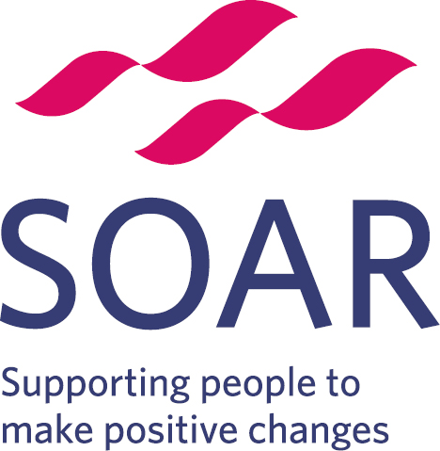 | Volunteer Role Description
Post title: Community Champion

Responsible to: Community Development Worker

Time commitment: Flexible

Purpose of role: We are looking for dedicated volunteers who can give a few hours a week to improve the health and wellbeing of people in North-East Sheffield. This is a really flexible role that gives you the opportunity to help people in a way that you are passionate about, from simply having ​conversations with people you already know, setting up a conversation or walking group, to befriending people who have become socially isolated.

Location: Various locations

What’s involved?
The role of the Community Champion is to:
- Help improve the health and wellbeing of people in Sheffield’s communities
- Help to identify the health and wellbeing needs of your local community
- Promote positive health messages in the local area
- Encourage people to make changes to improve their health and wellbeing
- Feedback on what you are hearing from people to your volunteer supervisor

What knowledge do I need?
As a Community Champion, it would be beneficial for you to know about:
- The things that make people healthy and unhealthy and willing to learn more
- Your local community

What skills do I need?
As a Community Champion, we ask that you:
- Are a good listener
- Can provide non-judgemental support and encouragement to people in difficult situations
- Are able to respect confidentiality even in difficult situations
- Are respectful and supportive of people regardless of background
- Are interested in helping people to find ways to solve their problems
- Enjoy meeting people and are friendly and enthusiastic
- Have a passion for improving people’s health and wellbeing

What can I gain from this role?
- Valuable experience in community-based work
- A better understanding of health and well-being needs
- A greater awareness of services and activities in your local area
- Training in areas such as understanding health and signposting
- Opportunity to meet new people and develop your social skills
- Access to SOAR’s training and employment services

Recruitment Process
Individuals interested in the role will be required to complete an application form and have an initial chat with the Community Development Worker at SOAR.

Training
Health Chats, making every contact count, and safeguarding. Additional optional training includes Accredited First Aid at work level 3.

Development
Expansion of personal networks, connection to community job clubs, and support from your volunteering supervisor in personal and professional development.

Support
You will be supported by a dedicated member of staff who will ensure that training and development needs are met during your time with SOAR, and provide ongoing support and supervision as needed.

Expenses
We will refund you for any reasonable expenses, such as travel and activity costs.

DBS Checks
A DBS check may be required for this role, but it will depend on the specific activities that you choose to do. Your supervisor will go through this with you before you start. We are still required to ask for two references for all roles.

For more information, please email: Penny.Thompson@longley4g.org.uk or call Penny Thompson on 0114 399 0520

